Experiment 9: Map Coloring (CSP)
Aim
To solve the Map Coloring Problem using CSP.
Objective
To assign different colors to neighbouring regions.
Algorithm
- Define regions.
- Assign colors.
- Check neighbouring regions.
- Ensure adjacent regions have different colors.
- Display the solution.
Flowchart
Start
|
Assign Color
|
Conflict?
/ \
Yes No
| |
Change Next Region
|
Repeat
|
Stop
Code
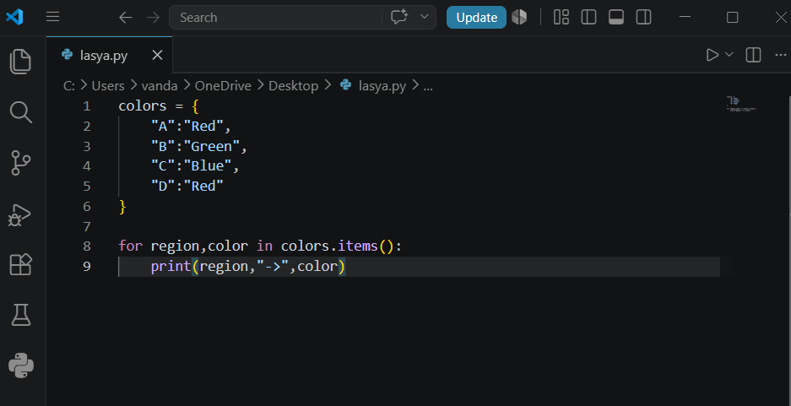
Output:
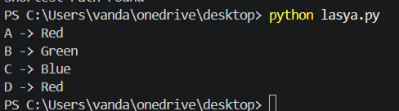
Result
The regions were colored successfully.
Conclusion
The CSP approach assigns colors without violating constraints.

